1. Agenda:
   1. D
2. 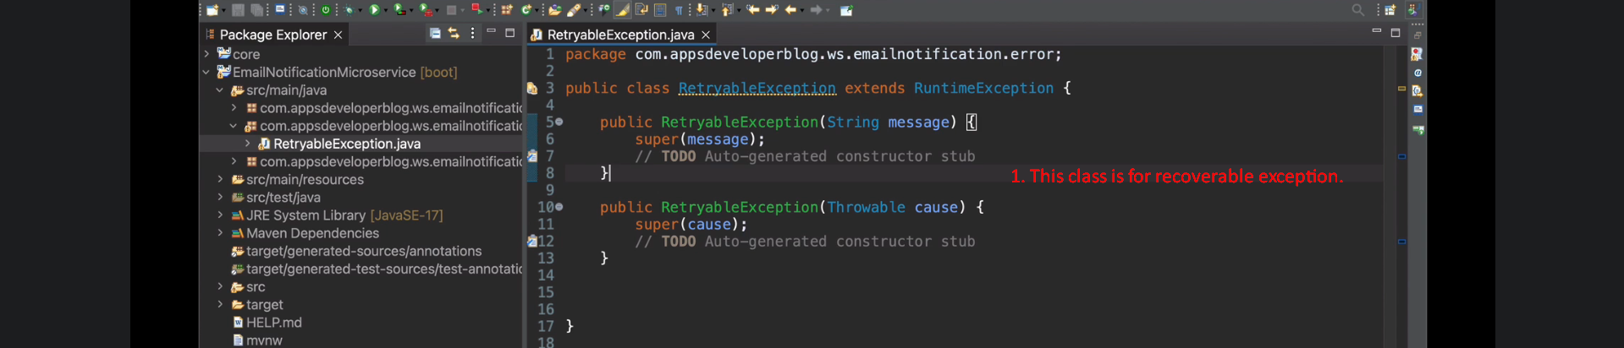
3. 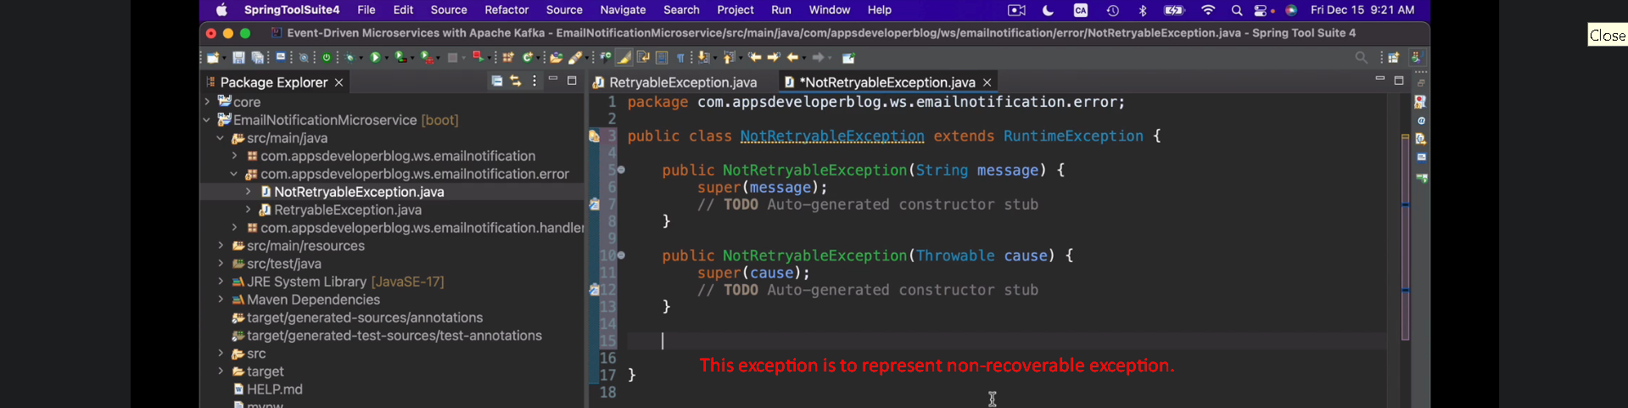
4. **NOTE**: Jatin -> Retry is performed only if msg marshalling is done successfully and exception occurs later on.  
   if during marshalling, exception occurs, the msg will be published to DLT without any second thought.